Dream Country: Monster Masquerade

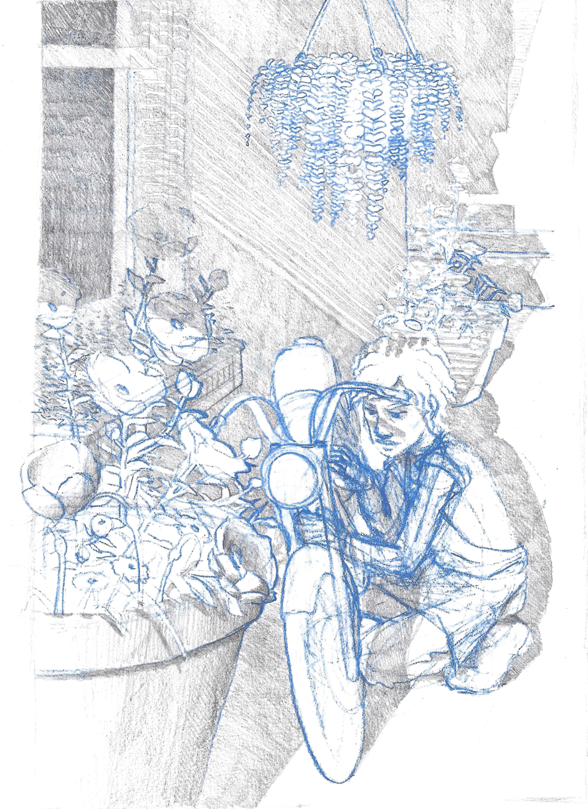

Table of Contents

Executive summary

Dust Jacket

Character Descriptions:

Player Character

Boris

Eiderdawn

Anette

Charis

Veda

Darius

Alvin

Preston

Pidge

Orlando

Transmuter

Creator

Destroyer

Gameplay Descriptions:

Intro

Rising Action

Game Branch One

Yes Path

No Path

Dream Re-Entry

Help or Hurt

Climax

Destroy

Transmute

Create

“Perfect” Bad End

“Perfect” Good End

High Concept:

What if you could share a dream with someone else? Find yourself in a dream of a masquerade ball full of enchanted monsters, befriend them and choose whether to return to the waking world or let the dream continue forever.

Game Genre:

Fantasy Dating Sim/Visual Novel

Platform:

PC, iOS, Android

Target Audience:

Primary: 17 – 35 -year-old women that typically consume dating games.

Secondary: 17 -45 -year-old consumers interested in platonic friendship stories and stories about non-binary characters.

Anticipated ESRB Rating:

E

Key Features:

Ten romanceable characters to choose from

Four-plus endings to play through

Write and receive letters from the characters

Explore the Monster Masquerade castle and grounds to find all the interactions and secrets

Tap along to fun dance minigames to unlock the monsters

Dust Jacket:

You recently convalesced from a long illness. It was thought to be fatal, but you miraculously recovered. At 19-years-old and with few friends or direction for what to do next, your only desire is to fix up your classic motorcycle and ride away. Frustrated at your mom’s insistence that you get your GED and apply for college, you escape into a dream that you are attending a masquerade ball unlike anything you have seen in waking life. Surrounded by uncanny, grotesque suitors you while the endless night away. Chatting, dancing and dining with the various monsters you begin to find they have a certain charm and magnetism you can’t fathom. A darker secret lies behind the dream world that hosts this elegant affair. Can you free your newfound companions from the endless ball? Or will you continue the masque forever?

Character Descriptions

Name:

One Sentence Description:

Convalescing from a mysterious illness that threw their normal life off track, all they want to do is get their vintage motorcycle fixed and feel free.

Appearance Description:

Our player character is a 5’7” light-skinned black 19-year-old. Their eyes are brown with hooded eyelids, and prominent cheekbones, lending them a friendly, heart-shaped face. They have a wide, slightly upturned nose and full lips. They wear their hair short, about three-to-four inches in length, forming curls and waves and flipping up at the neckline. They wear their hair minimally styled, parted above the right eye. Their hair is brown with naturally occurring auburn and golden highlights.

They wear a pair of woven motorcycle riding pants, and lace-up riding boots with a strap detail. On top is a plain white t-shirt, the short sleeves rolled up to the shoulder of the garment, but dipping off the actual shoulder due to the character’s thin frame. Over the outfit, our character wears a discarded bakery apron, stained with motor oil from repairing the motorcycle. Our player character is also seen wearing latex gloves to protect his hands while performing the repairs.

Visual Design:

|  |  |
| --- | --- |
|  |  |

Personality Architecture:

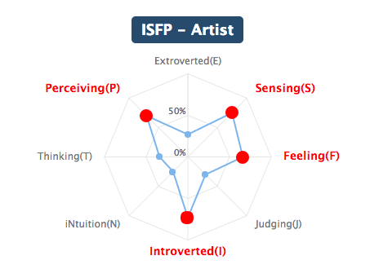

Backstory:

Attributes:

Behaviors:

Character Purpose:

Relationships with Other Characters:

Sample Dialogue:

Vocabulary of Motion:

ENGAGED

WHILE I’M WAITING

Name: Boris

One Sentence Description:

A cross between Porco Rosso and King Gator from “All Dogs go to Heaven.”

Appearance Description:

Boris is a Frog Monster, he stands at 5’8” tall and weighs 225 pounds. He is top-heavy, carrying most of his volume in his chest and his dual vocal sacs. Boris has muscled, powerful arms and a strong chest. His head should have a soft sloping shape when he is bored or disinterested, and a drawn, wide appearance like a full tulip when elated. The shape of his face and vocal sacs have a tendency to transmogrify based on whether he is speaking, singing, or at rest. His eyes have a golden color.

He wears a doublet and some variation of trousers, breeches, or hose depending on mood. He wears a shirt with full sleeves and narrow cuffs (long or short). The cuffs of his trousers or breeches should extend to his ankle, leaving his webbed feet exposed. He wears a wide belt with an ornate buckle and a shoulder holster beneath his doublet that holds a fine revolver. The holder should only be revealed when his doublet is open.

Boris has scars on the middle and ring fingers of his right hand.

Visual Design:

|  |  |
| --- | --- |
| /var/folders/nn/9zs186kw8xj8zq001s7c6t2r0000gq/T/com.evernote.Evernote/WebKitDnD.GtFU2y/Evernote Camera Roll 20161002 002730.jpg | /var/folders/nn/9zs186kw8xj8zq001s7c6t2r0000gq/T/com.evernote.Evernote/WebKitDnD.I5vLaw/Evernote Snapshot 20161002 001938.png |

Personality Architecture:

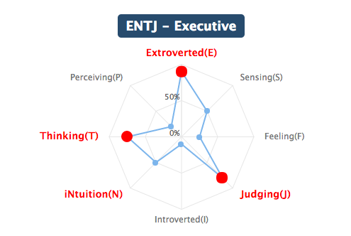

Backstory:

Free, unstructured play, in the country (image: clotheslines in the breeze), singing in the choir on Sundays. Former missionary or soldier? Obsessed with pistols and guns, appreciation of finely crafted, precisely machined items

When the PC was hospitalized he often felt drowned out by the voices around him, parents, doctors, nurses, lawyers. In his weakened state wished to have a booming voice that could silence all the cacophony around. A voice that would advocate for what made him feel best and stop the intrusive treatments that he already knew would cause more harm than good.

Attributes:

Behaviors:

Character Purpose:

Fear of Growing Old/ Mortality

Initial Problems: It’s time for him to retire from his dangerous work, but he’s not sure what to do in retirement with his battle-ready reflexes.

Current Problems: Wants to meet and befriend everyone at the party but some of the guests are cold, standoffish, or hard to pin down

How will it get worse: Darius will provoke him into a fight which will turn even more of the guests he wants to impress against him.

Relationships with Other Characters:

Closest Friends: Charis, Eiderdawn

Acquaintances: Anette

Enemies: Darius

Sample Dialogue:

Vocabulary of Motion:

ENGAGED

WHILE I’M WAITING

Name: Eiderdawn

One Sentence Description:

“He thinks I’m a spy or a gossip, just like everybody else; I’m not, I’m cautious, I’m vigilant, I’m a defender.”

Appearance Description:

A monstrous type of angel known as a throne. Eiderdawn stands at 6’4” tall and weighs 135 lbs. She is thin and angular with long legs and delicate fingers. Upon her shoulder sits her grotesque head of four constantly shifting fleshy bands from which wink numerous eyes. Like Boris the shape of her head shifts depending on her mood. The space where her head joins her neck is hidden by one large eye which remains stationary in relationship to the position of the camera, always facing it directly.

She wears a double-breasted jacket with long sleeves, pagoda shoulders, and a mandarin collar that cuts away from the body into a long tail. Beneath she wears leggings and thigh-high boots or closefitting shoepants. There is a large embellishment on the front of the jacket just above the center of her chest.

She often will engage in nervous gestures, crossing her arms over her chest, clasping her hands in front or behind her body. She has scars on her knees and shins.

Visual Design:

|  |  |
| --- | --- |
| /var/folders/nn/9zs186kw8xj8zq001s7c6t2r0000gq/T/com.evernote.Evernote/WebKitDnD.PBkKq8/Evernote Snapshot 20160910 211254.png | /var/folders/nn/9zs186kw8xj8zq001s7c6t2r0000gq/T/com.evernote.Evernote/WebKitDnD.iinKal/Evernote Camera Roll 20161002 235343.jpg |

Personality Architecture:

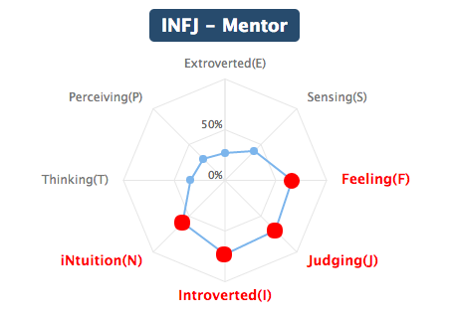

Backstory:

I get worried that people think I’m spying on them, or that I’m not interested in talking to them cause my eyes are always on something else. But I can’t help it. And everyone that sees me, judges me, with the same sense that is my curse. It’s really hard to look at myself and know who I am. I look so odd, not cuddly or graceful or talented like the others, and it’s so hard not to look at the others. But when I close my eyes I feel safe. The possibilities shrink down and there is just the current moment. And me expanding.

I can feel my mind and my heart. I can remember what it felt like to for someone to hold my hand and lead me everywhere, not knowing where I was going. I can remember getting upset and stubbing my toes on sidewalk curbs, and wondering what was flashing beyond the flesh of my eyelids. I remember what it felt like to be safe and present.

I love my eyes. They are what people notice about me, they let me stay alert and prepared! They come in so many colors and sizes. They make me like my favorite animal, the spider. Spiders humbly protect their households and keep intruders out! They guard doorways and thresholds and never ask for anything in return. Spiders never stop building, no matter how many times they watch their homes get swept away. I love my eyes, just some days I wish for a fight that might blacken almost all of them.

Eiderdawn grew up lonesome, with a single parent, and usually entertained herself. She is very conflicted about her purpose, clearly special, gifted from a young age, but disfigurement gave much unwanted attention.

Once the PC was sick, they felt constantly the center of unwanted attention, constantly under surveillance, voiceless could only helplessly watch what was happening to them. While bedridden the PC could only observe the world without participating in it.

Attributes:

Behaviors:

Character Purpose:

One of the earliest relationships that you develop in the game Eiderdawn helps you confront: Fear of being outcast, fear of showing true self, fear of being different and being rejected.

She believes she will save the world and she’s scared that’s a lie, that her appearance, everything she is a misfortune rather than a blessing.

Is afraid that the other partygoers dislike her, see her a busybody and think she is unattractive.

She will inadvertently reveal a secret about the masquerade and bring the wrath of the creator on her.

Relationships with Other Characters:

Closest Friends: Anette, Destroyer

Acquaintances: Charis, Boris

Enemies: Darius

Sample Dialogue:

Vocabulary of Motion:

ENGAGED

WHILE I’M WAITING

Name: Anette

One Sentence Description:

A highly competitive professional dancer, beauty is everything to her, and she’s willing to do anything to get it.

Appearance Description:

A centipede monster with a cherubic face (like Mae West). She should be depicted with her body curving into S forms.

She wears a dress that loops over her form with flounces trailing along the hemmed edges of her garment, mimicking the dress of a flamenco dancer.

Visual Design:

|  |  |
| --- | --- |
| /var/folders/nn/9zs186kw8xj8zq001s7c6t2r0000gq/T/com.evernote.Evernote/WebKitDnD.5dqMWv/Evernote Snapshot 20161002 001812.png |  |

Personality Architecture:

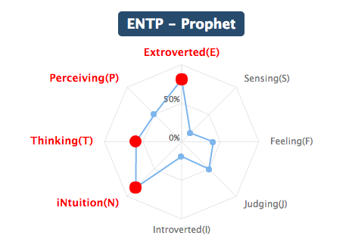

Backstory:

Being that they lived so far from civilization, she was born on the farm, her father having had experience birthing cows and horses, however there was a local doctor who came to oversee the process. She grew up on a solitary farm, she doesn’t like to talk about it because it is a boring subject to her, less fantastic than she imagines herself. She liked to spend her time alone, dancing in the fields as a child, and with time learned to turn her grace into an identity.

When the PC became very weak from their treatment and could no longer walk as well on their own, they imagined what it would be like to be someone who moved even better than they could when they were well, what a life like that would have been.

Attributes:

Behaviors:

Character Purpose:

Insecurity about looks

Relationships with Other Characters:

Closest Friends: Boris, Eiderdawn, the Creator

Acquaintances: All others

Enemies: Charis, Darius

Sample Dialogue:

Vocabulary of Motion:

ENGAGED

WHILE I’M WAITING

Name: Charis

One Sentence Description:

Appearance Description:

Charis is 4’ 11” and 280 lbs. She is short and plump, soft rounded curves. She is a slime jelly monster so she should be depicted as shiny, transparent, and dripping. She has dark green hair tied back into an elegant looped bun. As she moves throughout space she should trail or deposit slime.

Charis wears long strapless dresses with a train, fitted through the hips or down to the thighs as in a mermaid cut. Overtop she wears an organza apron with large ruffled flounces on the shoulder straps, and a white toque with a single curl escaping at her forehead.

Visual Design:

|  |  |
| --- | --- |
| /var/folders/nn/9zs186kw8xj8zq001s7c6t2r0000gq/T/com.evernote.Evernote/WebKitDnD.r9N6VT/Screenshot 2017-03-23 22.32.12.png | /var/folders/nn/9zs186kw8xj8zq001s7c6t2r0000gq/T/com.evernote.Evernote/WebKitDnD.vj2T8n/Screenshot 2017-03-23 22.32.01.png |

Personality Architecture:

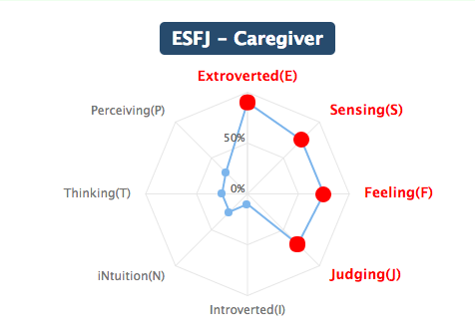

Backstory:

Lived in the city going nowherefast tryna so OOOHHWOOOWOOO OOOHWOOWOOO. Highrise apartment. Her Father was a Latin King, died early on in the process, her mother took up his mantel as a means of necessity to put food on the table. Father died when he was still young, Mother is a Latin Queen, her stepfather is the director of a food bank.

A time of hopelessness where the PC was no longer taking care of their own basic necessities, ie: feeding themselves, this character was to make food important and appealing to them again.

Attributes:

Behaviors:

Character Purpose:

Ashamed of not living up to family’s expectations (shirking responsibility), Afraid of losing her family, Causing harm to her family through her inaction/refusal to engage with her family’s gang.

She is overwhelmed having to cater the party every day.

Organizing the other party goers to assist her running the kitchen. Anette not viewing this enterprise as worthwhile will attempt to sabotage the organization of the kitchen and turn the partygoers against the idea of working.

Relationships with Other Characters:

Sample Dialogue:

Vocabulary of Motion:

ENGAGED

WHILE I’M WAITING

Name:Veda

One Sentence Description:

Appearance Description:

Veda is a cross between an owl and an elephant. She stands bipedal like Babar. Her face is covered in feathers surrounding her eyes.

Visual Design:

|  |  |
| --- | --- |
| /var/folders/nn/9zs186kw8xj8zq001s7c6t2r0000gq/T/com.evernote.Evernote/WebKitDnD.WyOwFN/Evernote Snapshot 20161023 182442.png |  |

Personality Architecture:

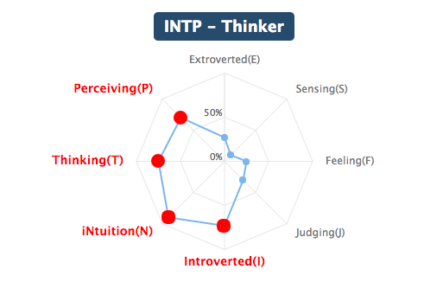

Backstory:

Moved to the United States when she was young. Mother was a Doctor, Father a Religious Leader

Fear of loss of intellect, Fear of Death.

Attributes:

Behaviors:

Character Purpose:

She can tell that the masquerade isn’t quite what it seems

Wants to learn more about the Dreamers, having caught on to the fact that more is going on than it seems

When she discovers that she isn’t real, it causes her great distress, and wishes to aid in destroying the dream, because she cannot reconcile being “wise” while also being fictional.

Fear of Intimacy, Fear of Attachment

Relationships with Other Characters:

Closest Friends: Boris, Anette, Eiderdawn

Acquaintances:

Enemies: Charis, Darius

Sample Dialogue:

Vocabulary of Motion:

ENGAGED

WHILE I’M WAITING

Name: Darius

One Sentence Description:

Appearance Description:

Darius stands 5’5” tall and weighs 190 lbs. He is a bat monster with 3 conjoined heads, each with a set of eyes and a mouth. Darius has only 2 large, prominent ears. He has wings that extend from his arms and torso that he wraps around himself like a cape.

Darius wears the torso of a tuxedo, with shirt, tailed jacket and bowtie, that tuck neatly into a cummerbund. His lower half should be covered by his fur or shoepants.

Visual Design:

|  |  |
| --- | --- |
| /var/folders/nn/9zs186kw8xj8zq001s7c6t2r0000gq/T/com.evernote.Evernote/WebKitDnD.2IUb6o/Evernote Camera Roll 20161113 213903.png | /var/folders/nn/9zs186kw8xj8zq001s7c6t2r0000gq/T/com.evernote.Evernote/WebKitDnD.R7TrF5/Evernote Camera Roll 20161104 185143.png |

Personality Architecture:

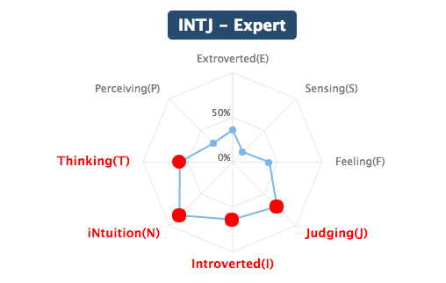

Backstory:

An old manor left to him by his father, his mother died when he was very young and he has little to no memory of her. His father raised him with the help of the staff of the manor, his father was old and bitter when he died, was never very close with his son. His father was very wealthy and inherited a large estate, his family having ties to much of the smaller business that were within his township. His mother was a commoner/poor, but very pretty. She was very delicate and died of illness when he was young.

Born of the PC being angry at the world during their illness, often casting away the people who cared for them in favor of solitude.

Attributes:

Behaviors:

Character Purpose:

He is conspiring to end the Dream, because he believes it will return him to his “kingdom”

No one at the party knew of him.

No one at the party respects him.

He will try to convince the player to end the dream because the Destroyer has told him it will free him, he doesn’t fully understand the consequences of this action.

Being misunderstood, fear of not being special.

Relationships with Other Characters:

Closest Friends: None

Acquaintances: The Destroyer, Eyeball Princess

Enemies: The Frog, Anette

Sample Dialogue:

Vocabulary of Motion:

ENGAGED

WHILE I’M WAITING

Name: Alvin

One Sentence Description:

Appearance Description:

Alvin eldritch horror from a Chuck Tingle novel. He is a horse with a human torso perched on his chest with a horse head and neck emerging from the top of the human torso.

At the beginning in the story he is bedridden. He should only appear as a horse’s head with the rest of him concealed underneath bedclothes. Later on in the story he will acquire a wheel chair that allows him to move through the castle.

Visual Design:

|  |  |
| --- | --- |
| /var/folders/nn/9zs186kw8xj8zq001s7c6t2r0000gq/T/com.evernote.Evernote/WebKitDnD.sEPUiv/Evernote Snapshot 20161023 182225.png |  |

Personality Architecture:

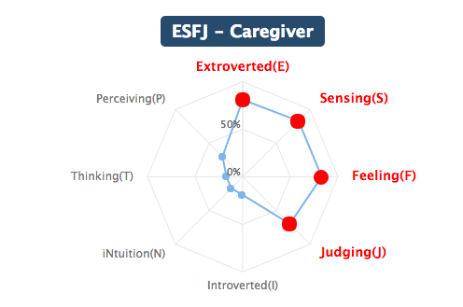

Backstory:

Never knew parents, grew up in an orphanage, ran away from it when he was 14 and made money any way he could on the street, when he raised enough money he bought himself a little plot so he could try to be self-sustaining.

Fear of becoming useless through injury or weakness.

First Job was swindling people in the underground, pickpocketing, gambling, doing what he can to survive. To be able to walk, to be able to return to his farm.

Attributes:

Behaviors:

Character Purpose:

He can’t walk anymore. He doesn’t think he will get better, and this means he will eventually have to give up the independence that is so important to him. He will be deceived into thinking that the Dreamers can undo what has happened to him, and joins Darius on his campaign to end the masquerade.

Fear of permanent disability, not being useful, not being productive.

Relationships with Other Characters:

Closest Friends: Charis, Darius

Acquaintances: All others

Enemies: Annette

Sample Dialogue:

Vocabulary of Motion:

ENGAGED

WHILE I’M WAITING

Name: Preston

One Sentence Description:

Appearance Description:

Is a Komodo Dragon. Walks both quadruped and bipedal. He has a scar on his head.

Usually depicted with Pidge draped about him.

Visual Design:

|  |  |
| --- | --- |
| /var/folders/nn/9zs186kw8xj8zq001s7c6t2r0000gq/T/com.evernote.Evernote/WebKitDnD.rjOcqp/Evernote Snapshot 20161023 182541.png |  |

Personality Architecture:

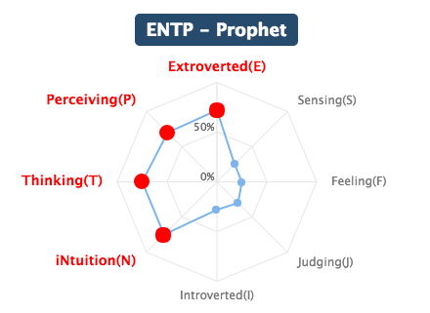Backstory:

His childhood home was violent, grew up in a household with a very controlling, narcissistic father. Mother is a lawyer, Father is in local politics.

Ran a successful payday loan franchise for years until he had to leave town when an unsatisfied customer came at him with a gun, by the time he settled again the regulations had changed and it wasn't worth getting back into the business. Currently looking for a new grift.

Attributes:

Behaviors:

Character Purpose:

Suspects that the masquerade isn't real. Doesn't want the dream to end, fears going back to normal life. He will lie, he will betray, he will assist the destroyer. Not sure how the Masquerade works looking for a way to take advantage. The other guests don't seem to care about his offers of money and success. He'll get frustrated and desperate to gain control after their rejections and ridicule.

Inferiority complex, afraid of others perceiving them as dumb.

Relationships with Other Characters:

Sample Dialogue:

Vocabulary of Motion:

ENGAGED

WHILE I’M WAITING

Name: Pidge

One Sentence Description:

Pidge is a snake, literally and figuratively.

Appearance Description:

Pidge is a silver snake with violet eyes. She wears choker with an enameled pin shaped like a bow tie.

Visual Design:

|  |  |
| --- | --- |
| /var/folders/nn/9zs186kw8xj8zq001s7c6t2r0000gq/T/com.evernote.Evernote/WebKitDnD.iLoxGf/Evernote Camera Roll 20161030 232638.png |  |

Personality Architecture:

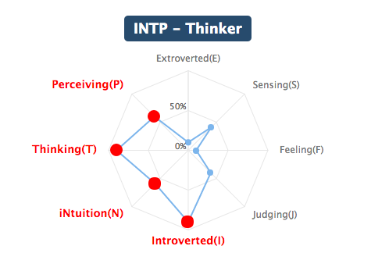

Backstory:

She was raised to be a very ambitious child, enrolled in pageants and talent shows. Grew up with Preston, best friends, inseparable.

Attributes:

Behaviors:

Character Purpose:

Fears dying poor and alone, losing Preston as her best friend.

Afraid of being alone, codependent.

Don't trust her. She is unhappy.

just along for the ride, Preston's plans are failing. Preston's relationship with the Destroyer will threaten her chances of benefiting from the takeover of the Monster Masquerade Castle.

Depending on the amount of information you have gathered on the Transmuter, Pidge will seek out a private audience with the player character. If you successfully build a friendship with Pidge, her turning will reveal that the Monsters of the Masquerade were manifested from the Player Character’s own insecurities.

Relationships with Other Characters:

Closest Friends: Preston

Acquaintances: Darius

Enemies: Anette, Orlando

Sample Dialogue:

Vocabulary of Motion:

ENGAGED

WHILE I’M WAITING

Name: Orlando

One Sentence Description:

Pitiful like Ross from friends, but hot?

Appearance Description:

A monster based on a Seraphim angel. His wings are appendages that resemble the body part of the siphonophore, Portuguese Man-of-War. They move according to his whim.

Visual Design:

|  |  |  |
| --- | --- | --- |
| /var/folders/nn/9zs186kw8xj8zq001s7c6t2r0000gq/T/com.evernote.Evernote/WebKitDnD.oV8HNy/Evernote Snapshot 20161023 182057.png | /var/folders/nn/9zs186kw8xj8zq001s7c6t2r0000gq/T/com.evernote.Evernote/WebKitDnD.C39QGK/IMG_4429.JPG | /var/folders/nn/9zs186kw8xj8zq001s7c6t2r0000gq/T/com.evernote.Evernote/WebKitDnD.o1NUol/IMG_4430.JPG |

Personality Architecture:

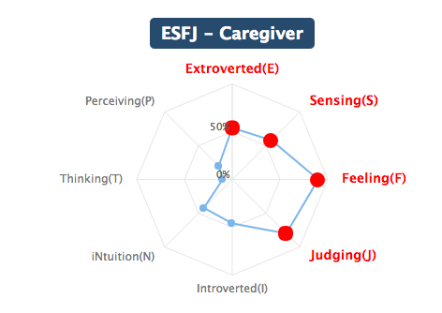

Backstory:

Attributes:

Behaviors:

Character Purpose:

Fear of never finding romantic fulfillment, being emasculated, fear of failure, insecurity/helplessness about controlling emotional vulnerability.

Relationships with Other Characters:

Sample Dialogue:

Vocabulary of Motion:

ENGAGED

WHILE I’M WAITING

Name: Transmuter

One Sentence Description:

Appearance Description:

Visual Design:

|  |  |
| --- | --- |
| /var/folders/nn/9zs186kw8xj8zq001s7c6t2r0000gq/T/com.evernote.Evernote/WebKitDnD.5MD4pw/IMG_3827.png |  |

Personality Architecture:

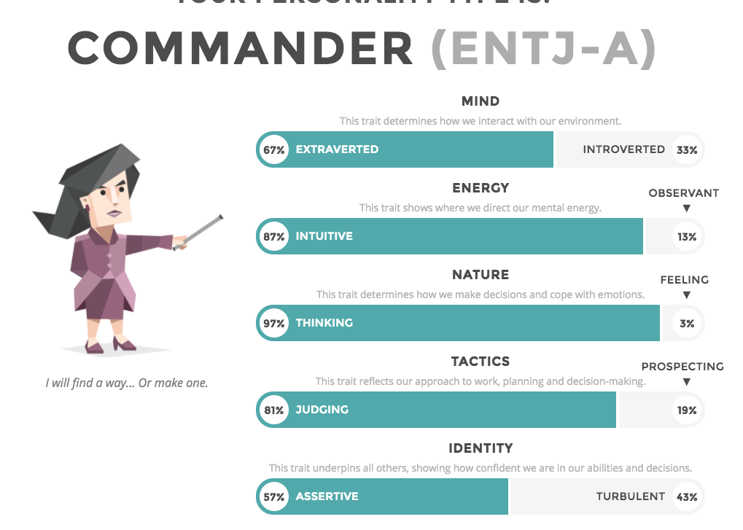

Backstory:

Attributes:

Behaviors:

Character Purpose:

Relationships with Other Characters:

Sample Dialogue:

Vocabulary of Motion:

ENGAGED

WHILE I’M WAITING

Name: Creator

One Sentence Description:

Appearance Description:

Visual Design:

|  |  |
| --- | --- |
| /var/folders/nn/9zs186kw8xj8zq001s7c6t2r0000gq/T/com.evernote.Evernote/WebKitDnD.Lvp7cz/Evernote Camera Roll 20161020 202702.jpg | /var/folders/nn/9zs186kw8xj8zq001s7c6t2r0000gq/T/com.evernote.Evernote/WebKitDnD.61YTHQ/IMG_3869.png |

Personality Architecture:

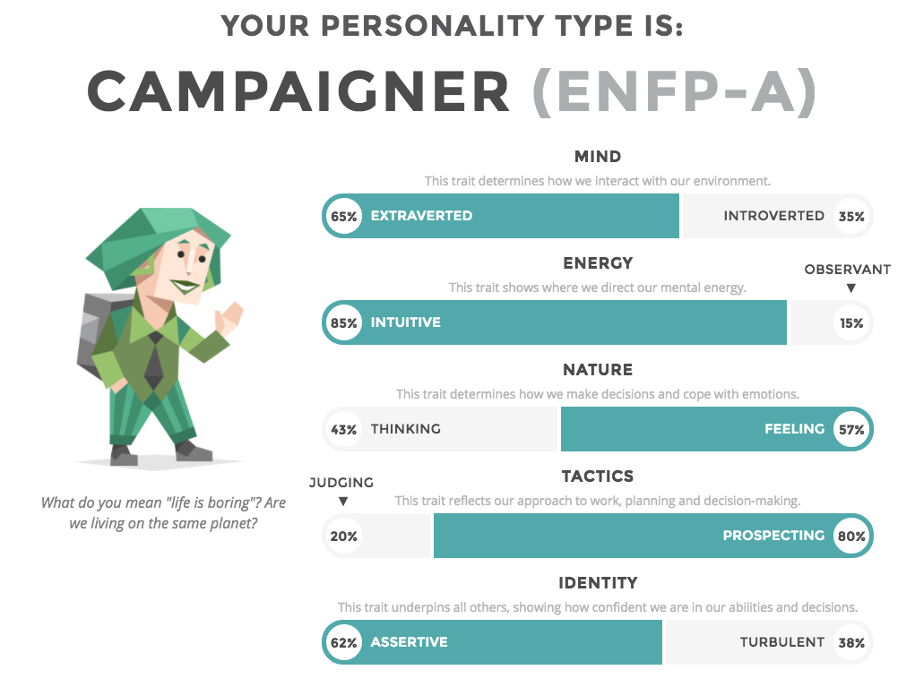

Backstory:

Attributes:

Behaviors:

Character Purpose:

Relationships with Other Characters:

Sample Dialogue:

Vocabulary of Motion:

ENGAGED

WHILE I’M WAITING

Name: Destroyer

One Sentence Description:

Appearance Description:

Visual Design:

|  |  |
| --- | --- |
| /var/folders/nn/9zs186kw8xj8zq001s7c6t2r0000gq/T/com.evernote.Evernote/WebKitDnD.XAbu4V/Evernote Camera Roll 20161019 230828.jpg | /var/folders/nn/9zs186kw8xj8zq001s7c6t2r0000gq/T/com.evernote.Evernote/WebKitDnD.BsitZx/Evernote Snapshot 20161019 231024.png |

Personality Architecture:

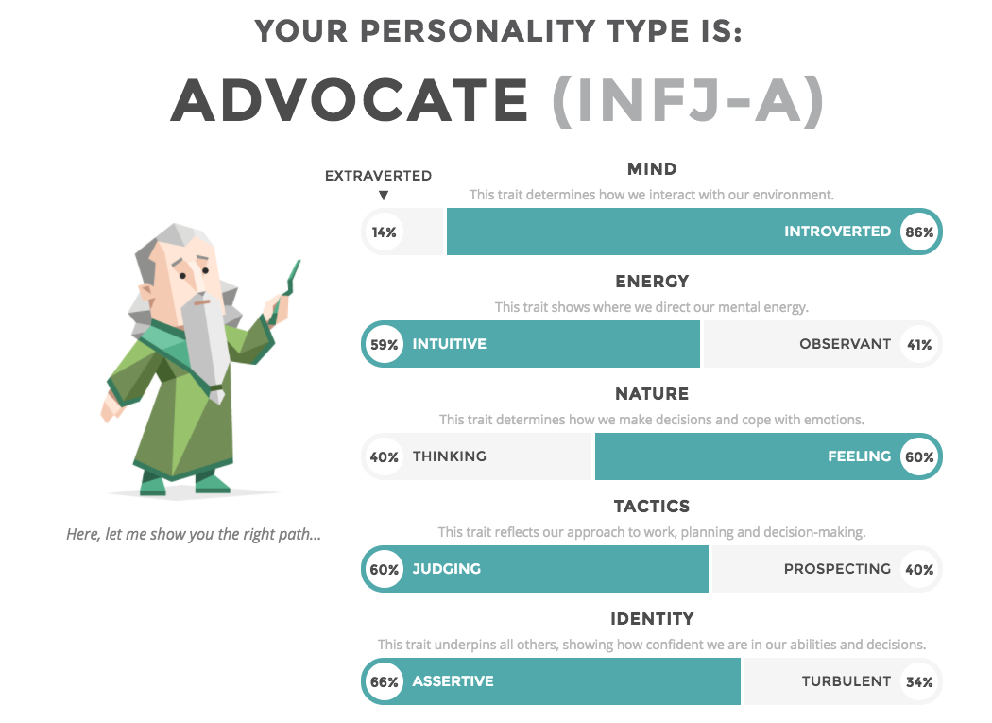

Backstory:

Attributes:

Behaviors:

Character Purpose:

Relationships with Other Characters:

Sample Dialogue:

Vocabulary of Motion:

ENGAGED

WHILE I’M WAITING

Citations:

Personality Tests:

Characters: https://www.arealme.com/16types/en/

Dreamers: https://www.16personalities.com/entj-personality